1. Grade Checker
Take a score as input and print the grade based on the following:
90+ : "A"
80-89 : "B"
70-79 : "C"
60-69 : "D"
Below 60 : "F"
here we used a basic if else statement to carry out marks and all.
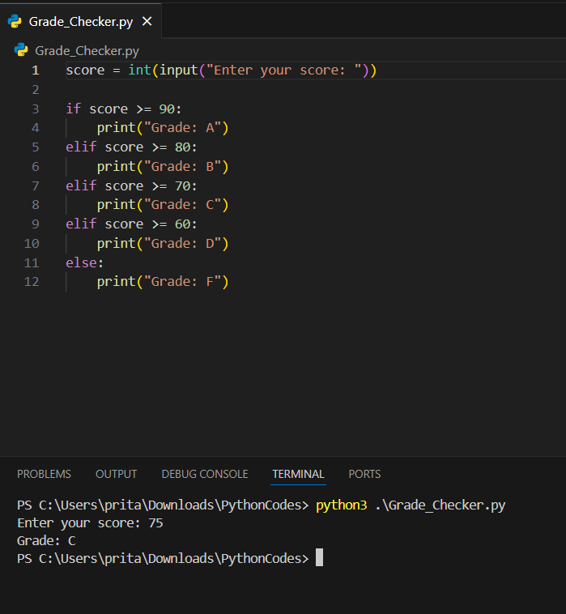
Explanation
- input() → takes marks from the user.
- int() → converts the input into a number.
- if-elif-else → checks different score ranges.
- Based on the condition, the program prints the corresponding grade.

2 Student Grades
Create a dictionary where the keys are student names and the values are their grades. Allow the user to:
Add a new student and grade.
Update an existing student’s grade.
Print all student grades.
Used dictionary and basic operations. Using if else:
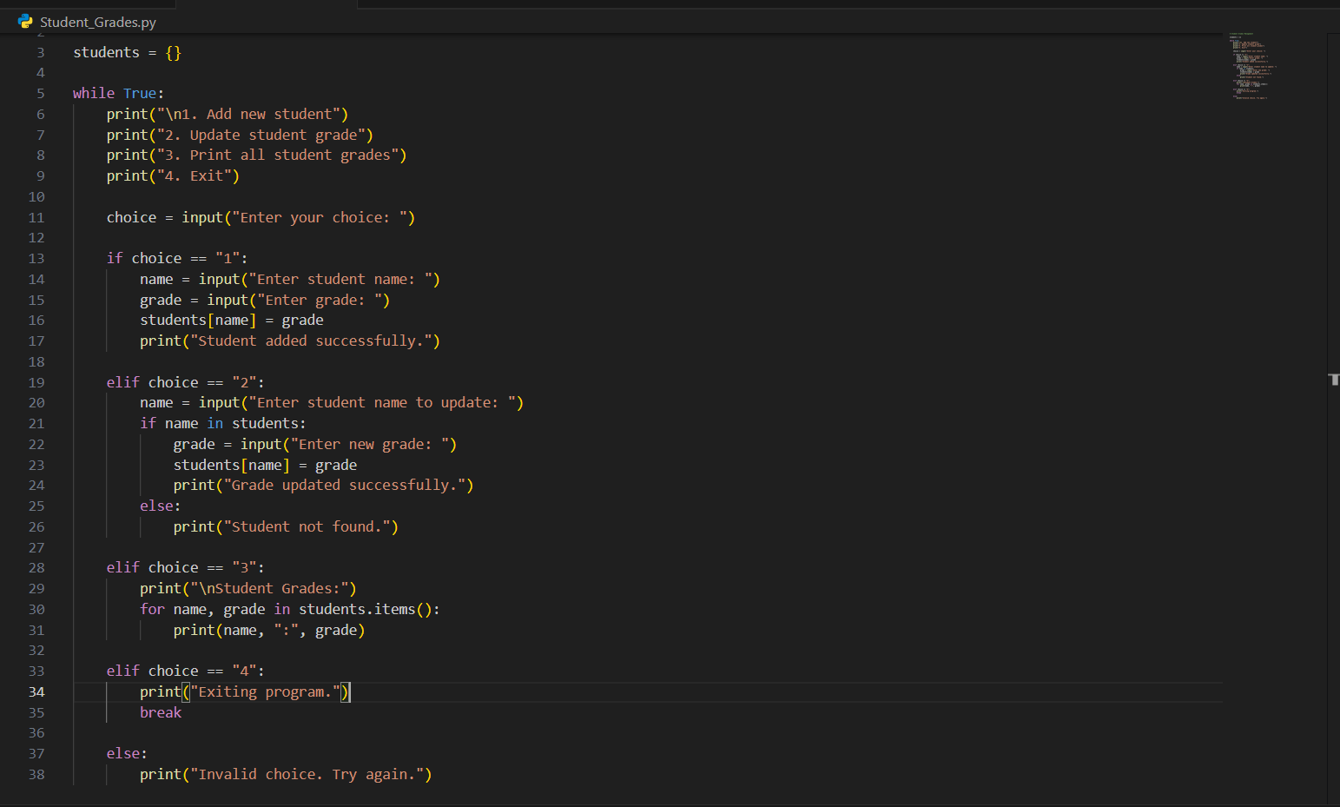
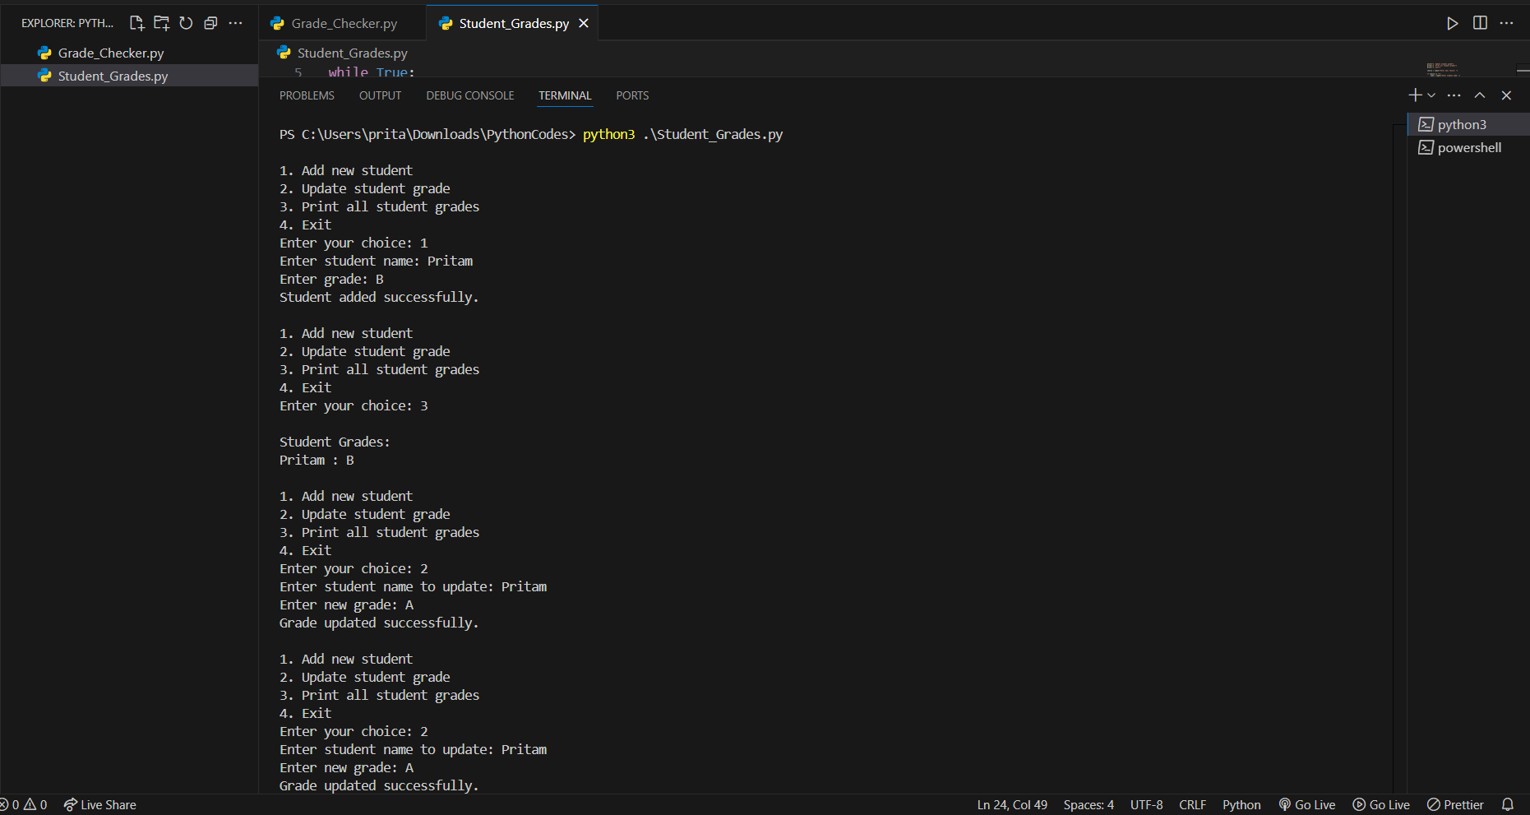
Explanation (for assignment)
- A dictionary named students is used to store student names as keys and grades as values.
- The program uses a while loop to repeatedly show options to the user.
- Option 1 allows adding a new student and their grade to the dictionary.
- Option 2 updates the grade of an existing student using an if condition to check if the student exists.
- Option 3 prints all student names and their grades using a for loop.
- Option 4 exits the program using break.
- if-elif-else statements are used to handle different user choices.

3.Write to a File
Write a program to create a text file and write some content to it.
Using file functions like write and open.
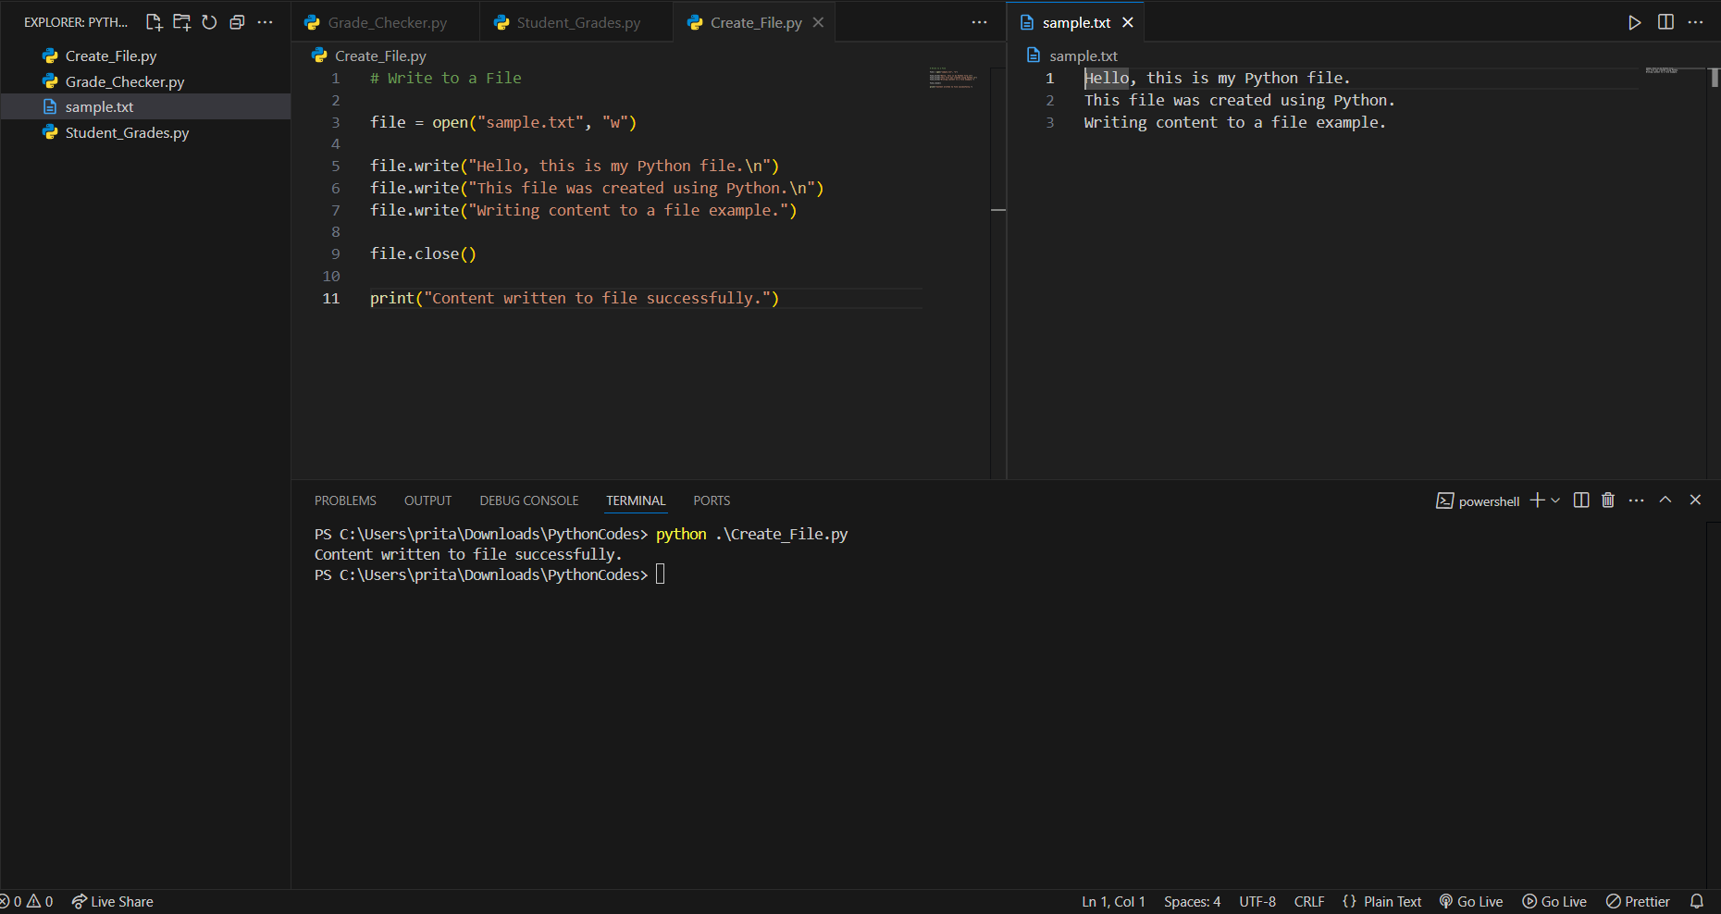
Explanation (for assignment)
- open("sample.txt", "w") → Opens a file named sample.txt in write mode. If the file does not exist, Python creates it.
- "w" means write mode.
- write() → Writes text into the file.
- \n → Moves the text to the next line.
- close() → Closes the file after writing.
- Finally, a message is printed to confirm the file was created.

4. Read from a File
We used open in read mode and file.read to read and print to display.
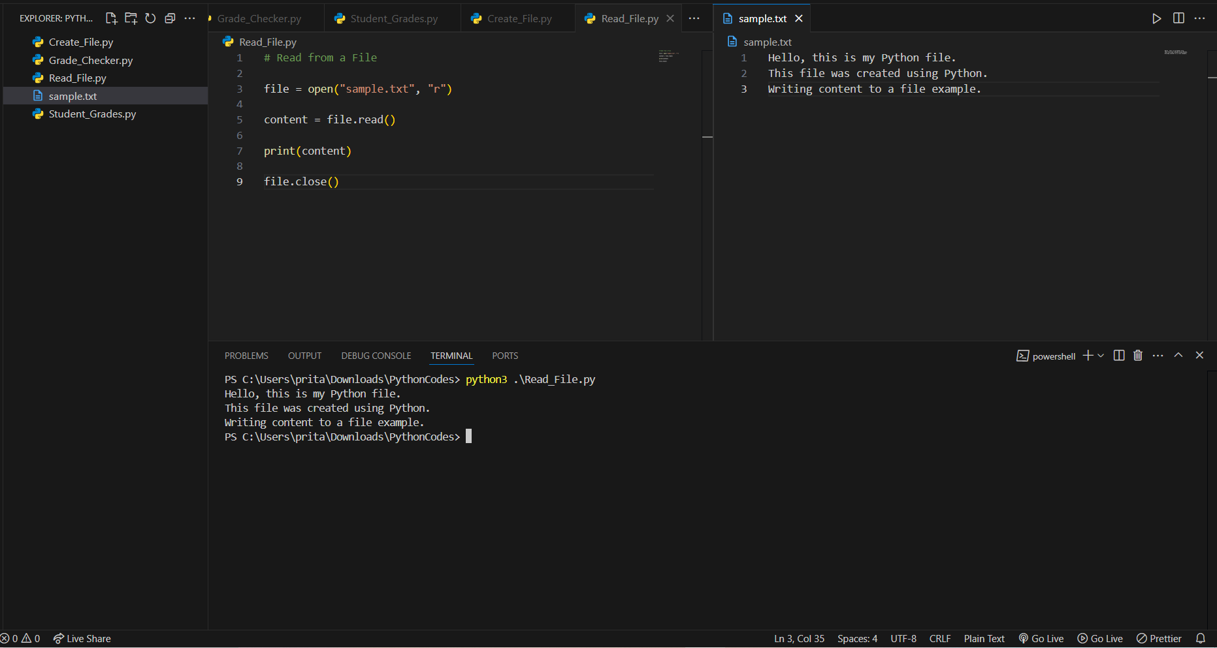
Explanation (for assignment)
- open("sample.txt", "r") → Opens the file sample.txt in read mode.
- "r" means read mode, which allows the program to read the file content.
- file.read() → Reads the entire content of the file.
- print(content) → Displays the content on the screen.
- file.close() → Closes the file after reading.

Submission Guidelines -: Attach Screenshots or command along with explanation and submit in doc(google doc or microsoft doc) format or share github link

